**Project 2**

Title

**Card War Game**

Course

**CIS-5**

Section

**40570**

Due Date

**February 12, 2022**

Author

**Liliana Darch**

**Introduction**

**Final version:**

**Project_Version_18_cardWarGame_FINAL VERSION**

**Title:**

Card War Game

**Number of players:**

2

**How to play:**

The game uses a standard 52-card deck of playing cards divided evenly and randomly between two players. Each player gets 26 random cards face down. Both player flip the top card at the same time, compare both cards and the player with the higher card wins both cards.

A war consist in a tie between the two player because both players flipped identical cards, each player lays three cards face-down, then each player flips one card face-up, compare the new face-up cards played and the player with the higher rank wins all the cards.

If the cards tie again then you have another war and repeat the process of the war and continue the process until there is a winner. If one player doesn’t have more cards to lay face-down during the war, he or she will lose the war.

The first player to collect all the cards wins.

**Card denomination:**

A is the highest card = 13

2 is the lowest card = 1

|  |  |  |  |  |  |  |  |  |  |  |  |  |  |
| --- | --- | --- | --- | --- | --- | --- | --- | --- | --- | --- | --- | --- | --- |
| Card | 2 | 3 | 4 | 5 | 6 | 7 | 8 | 9 | 10 | J | Q | K | A |
| Equal to | 1 | 2 | 3 | 4 | 5 | 6 | 7 | 8 | 9 | 10 | 11 | 12 | 13 |

**Flowchart**

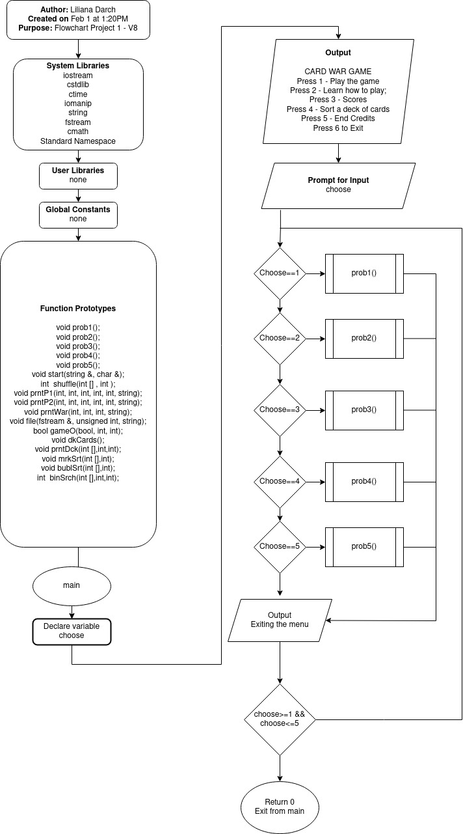

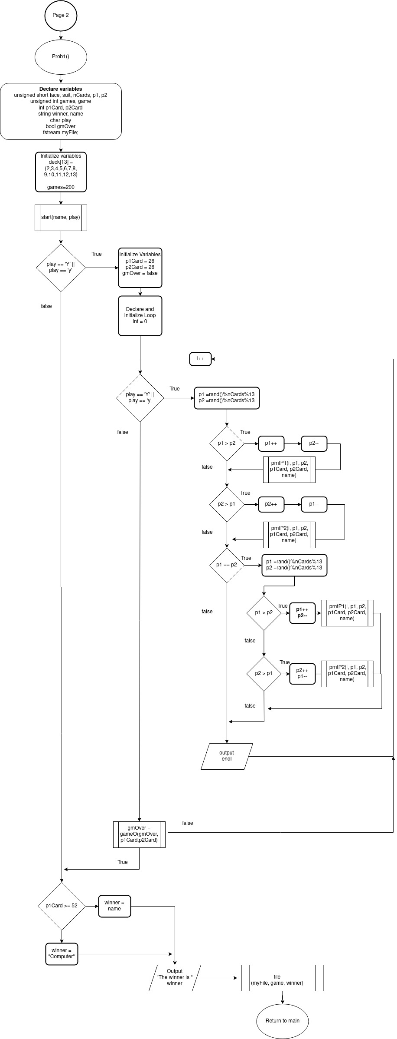

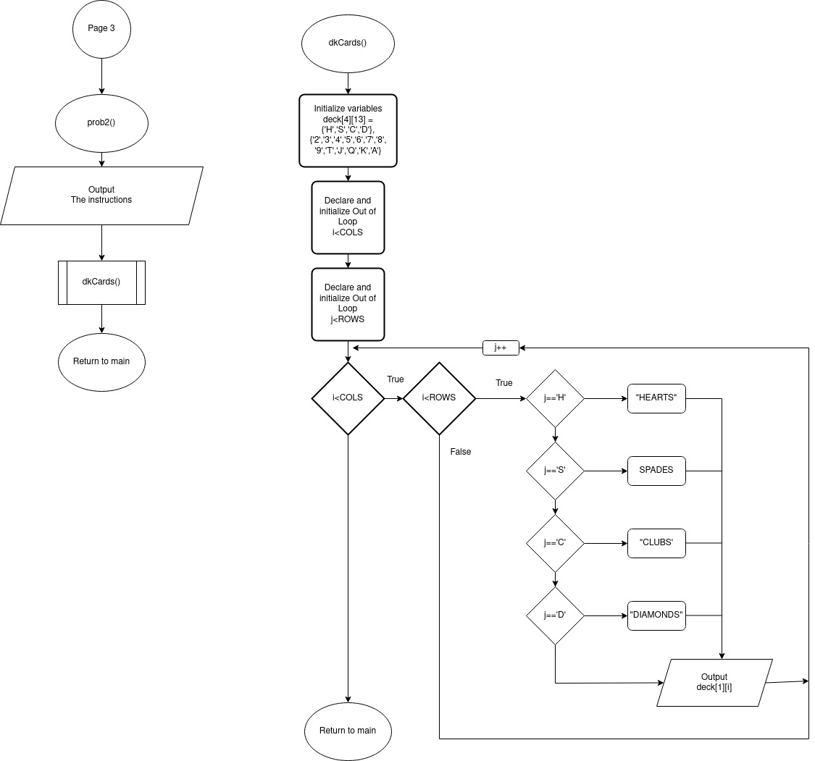

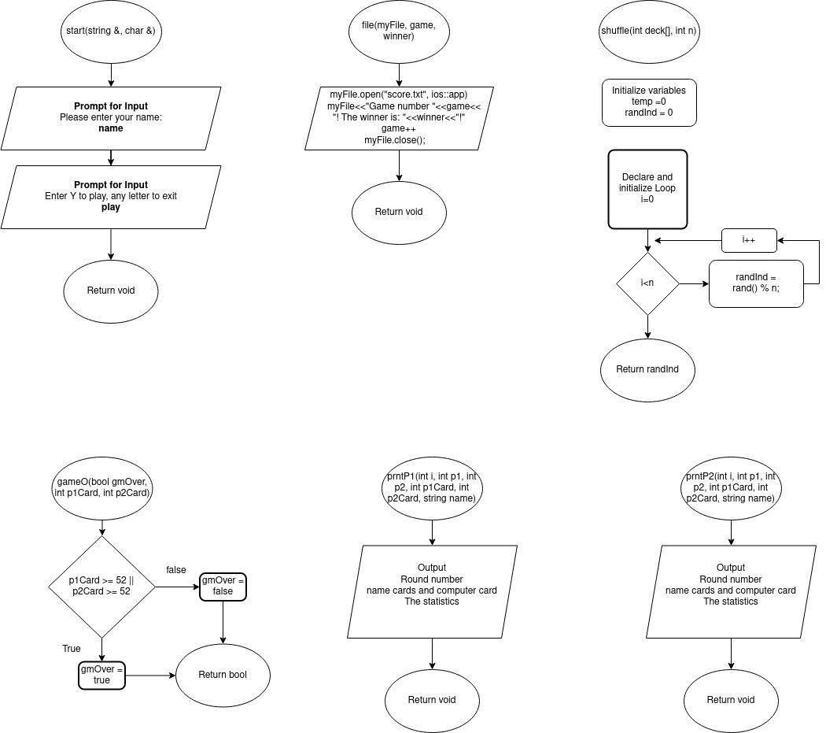

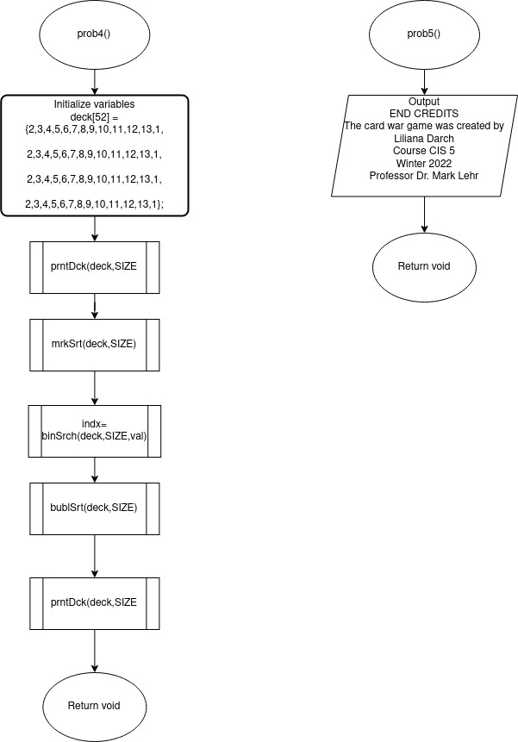

**Check of Sheets Project 2**

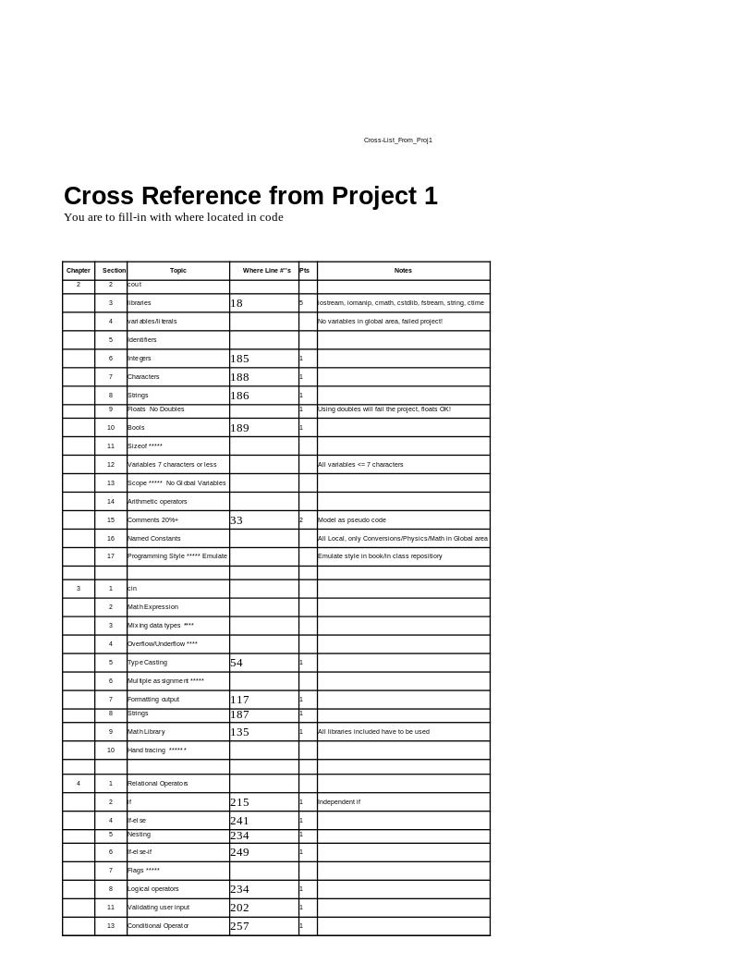

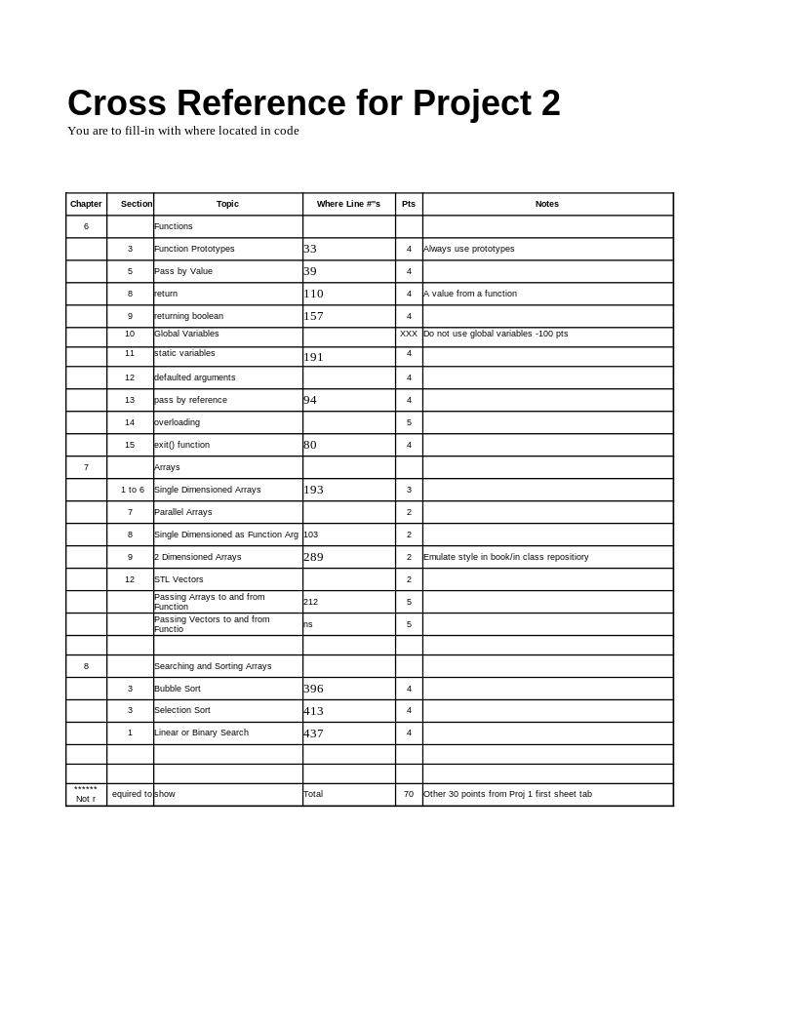

**Screenshots**

1. Main menu

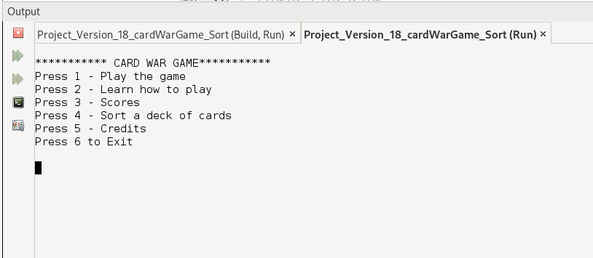

1. Main menu – Select option 1

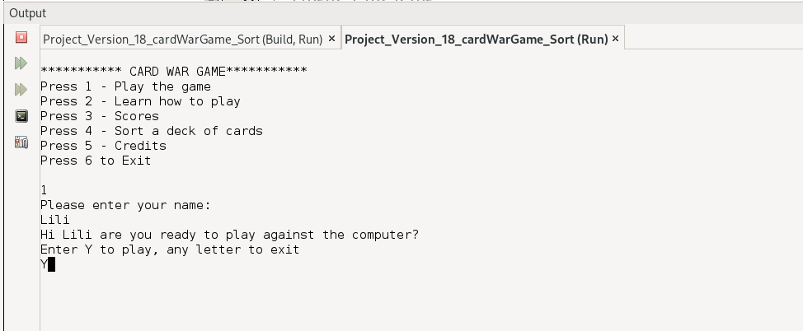

1. Option 1 – Playing the game

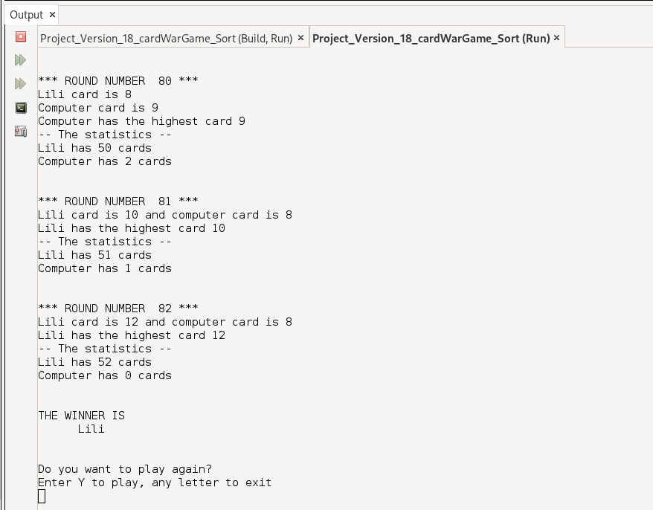

1. Option 1 – Back to main menu

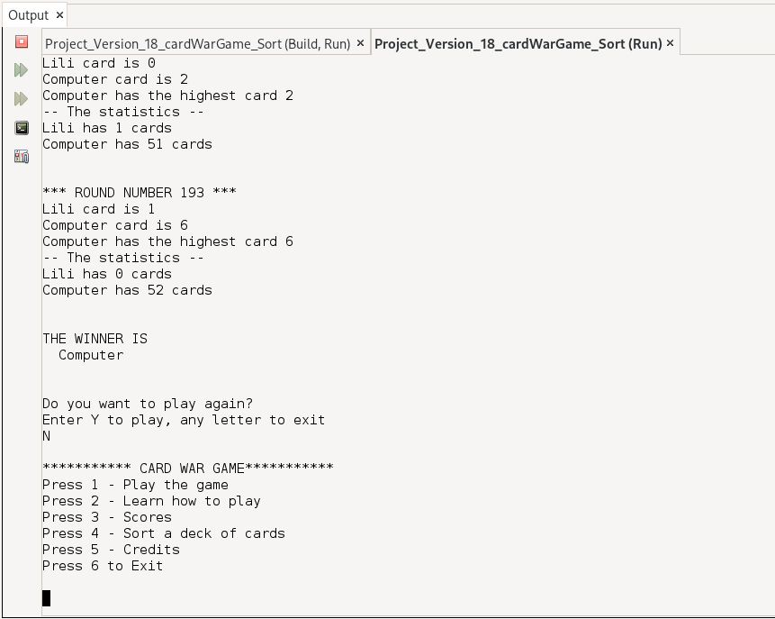

1. Option 2 – Learn how to play

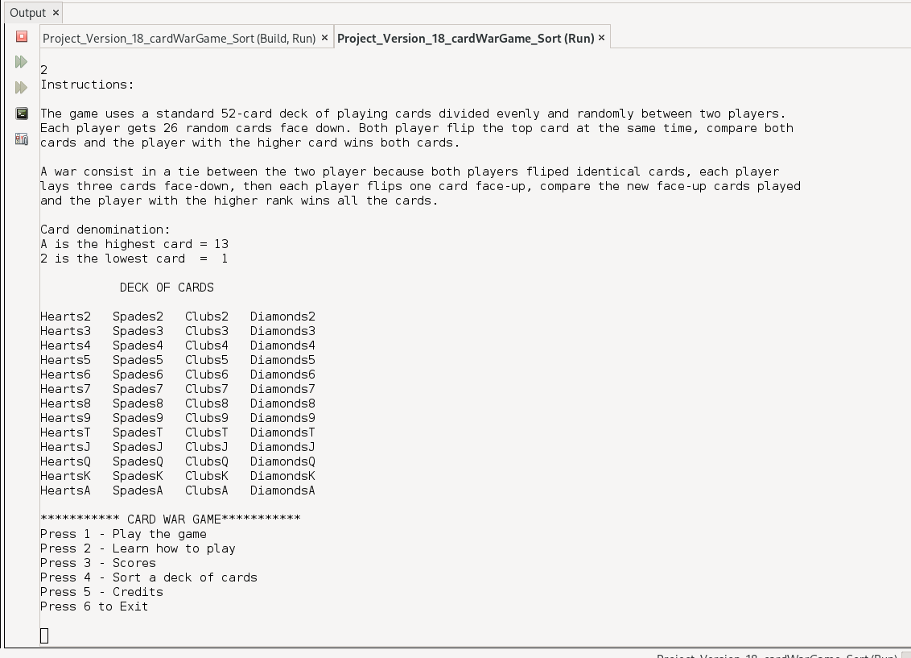

1. Option 3 – Scores – Using a file

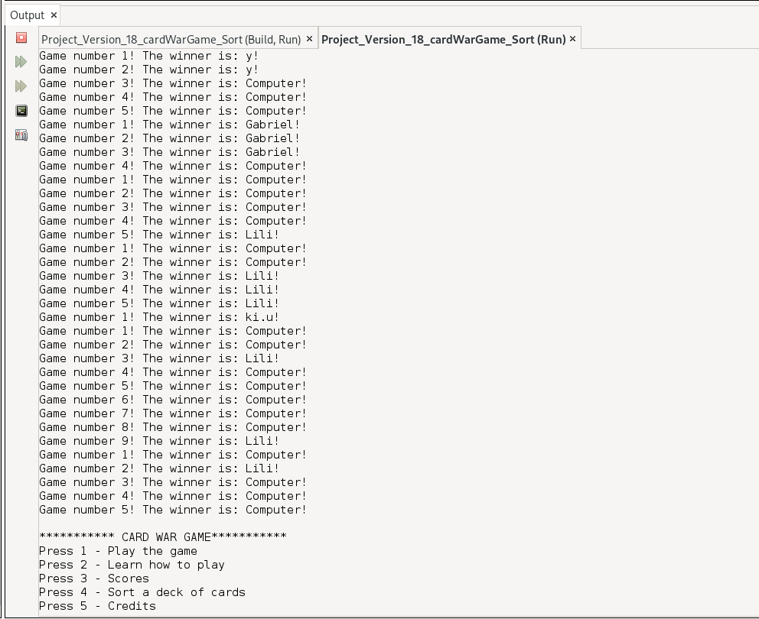

1. Option 4 – Sort a deck of cards and search

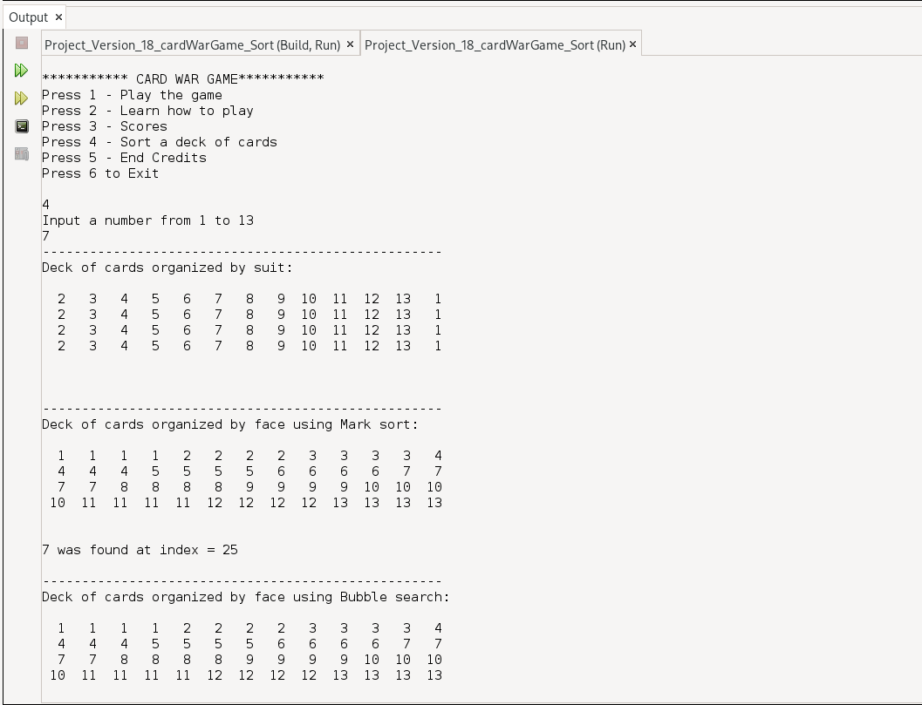

1. Option 5 – End credits

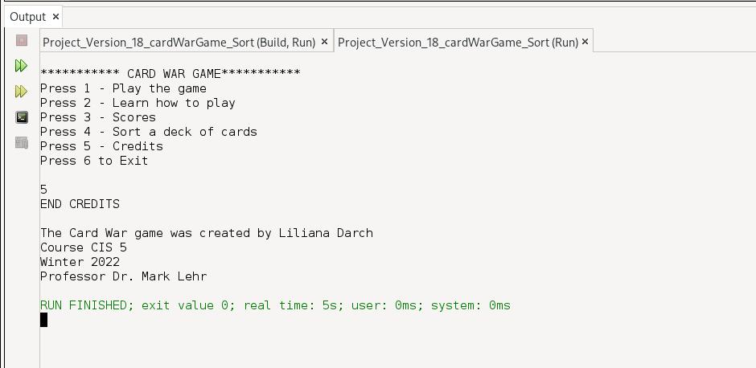

1. Option 6 – Exit main menu

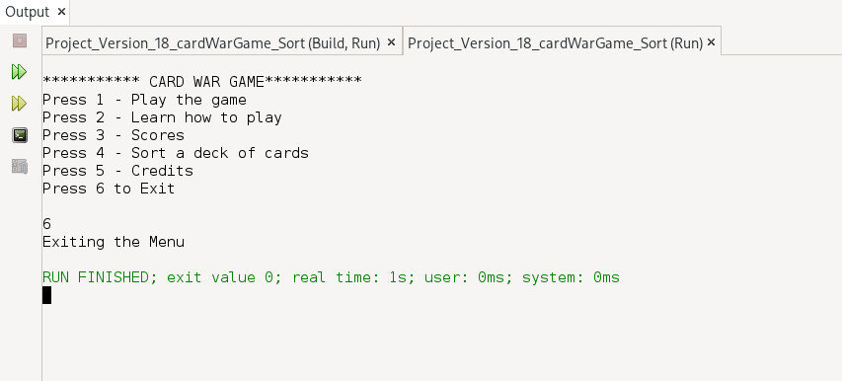

**Code**

/*

* File: main.cpp

* Author: Liliana Darch

* Created on Feb 12, 2022, 1:00 PM

* Purpose: Project Card War Game Version 18

*/

//Execution begins here!

//System Libraries

#include <iostream> //Input/Output Library

#include <cstdlib> //Srand

#include <ctime> //Time library

#include <iomanip> //Formatting Lbrary

#include <cmath> //Math Library - Log Function

#include <string> //String Library

#include <fstream> //File Library

using namespace std; //STD Name-space where Library is compiled

//User Libraries

//Global Constants not Variables

//Math/Physics/Science/Conversions/Dimensions

//Function Prototypes

void prob1(); //Main menu option 1

void prob2(); //Main menu option 2

void prob3(); //Main menu option 3

void prob4(); //Main menu option 4

void prob5(); //Main menu option 5

void start(string &, char &); //Function to start the game

int shuffle(int [] , int ); //Function to shuffle the deck of cards

void prntP1(int, int, int, int, int, string); //Function to print if player 1 won the round

void prntP2(int, int, int, int, int, string); //Function to print if player 2 won the round

void prntWar(int, int, int, string); //Function to print if we have a war on that round

void file(fstream &, unsigned int, string); //Function to append in the file

bool gameO(bool, int, int); //Function to check if the player would like to keep playing

void dkCards(); //Function to print the deck of cards using a 2d dimension array

void prntDck(int [],int,int); //Function to print the deck of cards

void mrkSrt(int [],int); //Function Mark sort

void bublSrt(int [],int); //Function Bubble sort

int binSrch(int [],int,int); //Function binary search

//Code Begins Execution Here with function main

int main(int argc, char** argv) {

//Set random number seed once here

srand(static_cast<unsigned int>(time(0)));

//Declare variables here

int choose;//Choose a problem

//Initialize variables here

do{

//Display the menu

cout<<endl;

cout<<"*********** CARD WAR GAME***********"<<endl;

cout<<"Press 1 - Play the game"<<endl;

cout<<"Press 2 - Learn how to play"<<endl;

cout<<"Press 3 - Scores"<<endl;

cout<<"Press 4 - Sort a deck of cards "<<endl;

cout<<"Press 5 - End Credits"<<endl;

cout<<"Press 6 to Exit "<<endl;

cout<<endl;

cin>>choose;

//Display the Solution to the problems

switch(choose){

case 1:prob1();break;

case 2:prob2();break;

case 3:prob3();break;

case 4:prob4();break;

case 5:prob5();break;

default:cout<<"Exiting the Menu"<<endl;

}

}while(choose>=1 && choose<=3);

return 0;

}

//************************************************

// GAME FUNCTIONS *

//************************************************

//Function ask for player's name and check if the player would like to play

void start(string &name, char &play){

cout<<"Please enter your name: "<<endl; //Ask for the player's name

cin>>name; //Read the player name

cout<<"Hi "<<name<<" are you ready to play against the computer?"<<endl;

cout<<"Enter Y to play, any letter to exit"<<endl;

cin>>play; //Read the user input about playing again

}

//Function to Shuffle the deck of cards

int shuffle(int deck[], int n){

int temp = 0;

int randInd = 0;

for(int i = 0; i < n; i++){

randInd = rand() % n;

}

return randInd;

}

//Print the player 1 and 2 card and the statistics

void prntP1(int i, int p1, int p2, int p1Card, int p2Card, string name){

cout<<endl;

cout<<"*** ROUND NUMBER "<<setw(3)<<i<<" ***"<<endl;

cout<<name<<" card is "<<p1<<" and computer card is "<<p2<<endl;

cout<<name<<" has the highest card "<<p1<<endl;

cout<<"-- The statistics --"<<endl;

cout<<name<<" has "<<abs(p1Card)<<" cards"<<endl;

cout<<"Computer has "<<abs(p2Card)<<" cards"<<endl;

}

//Function to Print the player 1 and 2 card and the statistics

void prntP2(int i, int p1, int p2, int p1Card, int p2Card, string name){

cout<<endl;

cout<<"*** ROUND NUMBER "<<setw(3)<<i<<" ***"<<endl;

cout<<name<<" card is "<<p1<<endl;

cout<<"Computer card is "<<p2<<endl;

cout<<"Computer has the highest card "<<p2<<endl;

cout<<"-- The statistics --"<<endl;

cout<<name<<" has "<<abs(p1Card)<<" cards"<<endl;

cout<<"Computer has "<<abs(p2Card)<<" cards"<<endl;

}

//Function to Print the war message player 1 and 2 card have matching cards

void prntWar(int i, int p1, int p2, string name){

cout<<endl;

cout<<"*** ROUND NUMBER "<<setw(3)<<i<<" ***"<<endl;

cout<<name<<" card is "<<p1<<endl;

cout<<"Computer card is "<<p2<<endl;

cout<<"*** WE HAVE A WAR ***"<<endl;

}

//Function to Append the winner to the file score.txt

void file(fstream &myFile, unsigned int game, string winner){

myFile.open("score.txt", ios::app); // Open a file

myFile<<"Game number "<<game<<"! The winner is: "<<winner<<"!"<<endl; //Output in the file

myFile.close();

}

//Function that Check if we have a winner every round

bool gameO(bool gmOver, int p1Card, int p2Card){

if( p1Card >= 52 || p2Card >= 52 ){ //Set the bool to true so the game is over

return true;

}

else{

return false;

}

}

//*************************************************

// MAIN MENU *

//*************************************************

//Option 1 from main menu - Play the game

void prob1(){

//Set Random Number seed

srand(static_cast<unsigned int>(time(0)));

//Declare Variable Data Types and Constants

unsigned short face, suit, //variables for the face and suit of the deck of cards

nCards, //number of cards in a deck

p1, p2; //Player one and player two

unsigned int games, game; //The amount of rounds available to play

int p1Card, p2Card; //The amount of cards that each player has every round

string winner; //Holds the winner

string name; //Holds the name of player 1

char play; //Validates the user input keep playing

bool gmOver; //To check if we have a winner and a looser

fstream myFile; //File to hold the winner from each game

const int SIZE=13;

int deck[SIZE] = {2,3,4,5,6,7,8,9,10,11,12,13};

//Initialize Variables

start(name, play); //Calling the start game function

games=200; // We can play these game no more than 200 rounds

while (play == 'Y' || play == 'y'){ //Checks if the user would like to play the game

p1Card = 26; //Initialize player 1 with 26 cards

p2Card = 26; //Initialize player 2 with 26 cards

gmOver = false; //Check if there was a winner and a looser

//Start the game

do {

for(int i = 0; i<games && !gmOver; i++){

p1 = shuffle(deck, 13); //Assign the random card to Player 1

p2 = shuffle(deck, 13); //Assign the random card to Player 2

if (p1 > p2){ //If player 1 has the highest card

p1Card++; //Adds 1 card to player 1

p2Card--; //Subtract 1 card to player 2

prntP1(i, p1, p2, p1Card, p2Card, name); //Call the print Player 1 function

}

if (p1 < p2){ // If player 1 has the highest card

p2Card++; //Adds 1 card to player 2

p1Card--; //Subtract 1 card to player 2

prntP2(i, p1, p2, p1Card, p2Card, name); //Call the print Player 2 function

}

if(p1 == p2) { //If we get a match, we have a war!!

prntWar(i, p1, p2, name); //Call the print war function

p1 = shuffle(deck, 13); //Assign the random card to Player 1

p2 = shuffle(deck, 13); //Assign a new the random card to Player 2 to play the war

cout<<endl;

if (p1 > p2){ // If player 1 has the highest card

if ((p1Card <48) || (p2Card <48)) { //control the amount of cards played

p1Card = p1Card + 4; //Add 4 card to player 1

p2Card = p2Card - 4; //Subtract 4 card to player 2

}

prntP1(i, p1, p2, p1Card, p2Card, name); //Call the print Player 1 function

} else{ //If player 2 has the highest card

if ((p1Card <=48) || (p2Card <=48)){

p2Card = p2Card + 4; //Add 4 card to player 2

p1Card = p1Card - 4; //Subtract 4 card to player 1

}

prntP2(i, p1, p2, p1Card, p2Card, name); //Call the print Player 2 function

}

}else {

cout<<endl;

}

gmOver = gameO(gmOver, p1Card,p2Card); //Call the game over function

}

} while (gmOver == false); //Keep playing while boolean is equal to false

winner = p1Card >= 52 ? name:"Computer"; //Assign the winner player to the winner variable

cout<<endl<<"THE WINNER IS"<<endl;

cout<<setw(10)<<winner<<endl; //Output the winner

cout<<endl<<endl; //close the file

game++; // counts how many games were played

file(myFile, game, winner); //Call the File function

cout<<"Do you want to play again?"<<endl; //Ask if the user would like to play again

cout<<"Enter Y to play, any letter to exit"<<endl;

cin>>play; //Read the user input about playing again

}

}

//************************************************

// OPTION 2 MAIN MENU FUNCTION *

//************************************************

//Function to print the deck of cards using a 2d dimension array

void dkCards(){

//Declare Variables

const int ROWS = 4;

const int COLS = 13;

char deck[ROWS][COLS] = {

{'H','S','C','D'},

{'2','3','4','5','6','7','8','9','T','J','Q','K','A'}

};

cout<<" DECK OF CARDS"<<endl<<endl;

for (int i = 0; i < COLS; i++) {

for (int j = 0; j < ROWS; j++) {

string suit; //switch the suit based on index of array

switch (deck[0][j]) {

case 'H': suit = "Hearts"; break;

case 'S': suit = "Spades"; break;

case 'C': suit = "Clubs"; break;

case 'D': suit = "Diamonds"; break;

}

cout << suit << deck[1][i] << " "; //output suit and current number

}

cout << endl;

}

}

//Option 2 from main menu - Learn how to play

void prob2(){

cout<<"Instructions:"<<endl<<endl;

cout<<"The game uses a standard 52-card deck of playing cards divided evenly and randomly between two players."<<endl;

cout<<"Each player gets 26 random cards face down. Both player flip the top card at the same time, compare both"<<endl;

cout<<"cards and the player with the higher card wins both cards."<<endl<<endl;

cout<<"A war consist in a tie between the two player because both players fliped identical cards, each player"<<endl;

cout<<"lays three cards face-down, then each player flips one card face-up, compare the new face-up cards played"<<endl;

cout<<"and the player with the higher rank wins all the cards."<<endl;

cout<<endl;

cout<<"Card denomination:"<<endl;

cout<<"A is the highest card = 13"<<endl;

cout<<"2 is the lowest card = 1"<<endl<<endl;

dkCards(); //Calling Function to print the deck of cards using a 2d dimension array

}

//Option 3 from main menu - Scores

//Function to read the file

void prob3(){

fstream myFile;

myFile.open("score.txt", ios::in);

if(!myFile.is_open()){

cout<<"Unable to read file"<<endl;

}

if (myFile.is_open()){

string line;

while(getline(myFile, line)){

cout<<line<<endl;

}

}

myFile.close();

}

//Option 4 from main menu - Sort a deck of cards

void prob4(){

//Declare Variables

int val, indx;

const int SIZE=52;

int deck[SIZE] = {2,3,4,5,6,7,8,9,10,11,12,13,1,

2,3,4,5,6,7,8,9,10,11,12,13,1,

2,3,4,5,6,7,8,9,10,11,12,13,1,

2,3,4,5,6,7,8,9,10,11,12,13,1};

cout<<"Input a number from 1 to 13"<<endl;

cin>>val;

//Display the outputs

cout<<"---------------------------------------------------"<<endl;

cout<<"Deck of cards organized by suit:"<<endl;

prntDck(deck,SIZE,13); //Calling function

cout<<endl<<endl;

cout<<"---------------------------------------------------"<<endl;

//Display the outputs

cout<<"Deck of cards organized by face using Mark sort:"<<endl;

mrkSrt(deck,SIZE); //Calling function to sort

prntDck(deck,SIZE,13);

cout<<endl;

indx=binSrch(deck,SIZE,val);

cout<<val<<" was found at index = "<<indx<<endl;

cout<<endl;

//Display the outputs

cout<<"---------------------------------------------------"<<endl;

cout<<"Deck of cards organized by face using Bubble search:"<<endl;

bublSrt(deck,SIZE); //Calling function to sort

prntDck(deck,SIZE,13);

}

//************************************************

// OPTION 4 MAIN MENU FUNCTION *

//************************************************

//Function Bubble search

void bublSrt(int deck[],int n){

bool swap;

do{

swap=false;

n--;

for(int i=0;i<n;i++){

if(deck[i]>deck[i+1]){

swap=true;

int temp=deck[i];

deck[i]=deck[i+1];

deck[i+1]=temp;

}

}

}while(swap);

}

//Function to sort the deck of cards

void mrkSrt(int deck[],int n){

for(int pos=0;pos<n-1;pos++){

for(int i=pos+1;i<n;i++){

if(deck[pos]>deck[i]){

int temp=deck[pos];

deck[pos]=deck[i];

deck[i]=temp;

}

}

}

}

//Function to print the deck of cards

void prntDck(int deck[],int n,int perLine){

cout<<endl;

for(int i=0;i<n;i++){

cout<<setw(3)<<deck[i]<<" ";

if(i%perLine==(perLine-1))cout<<endl;

}

cout<<endl;

}

//Function Binary search

int binSrch(int deck[],int n,int val){

int high=n-1,low=0;

do{

int middle=(high+low)/2;

if(val==deck[middle]){

return middle;

}else if(val<deck[middle]){

high=middle-1;

}else{

low=middle+1;

}

}while(low<high);

return -1;

}

//Option 5 from main menu - End credits

void prob5(){

cout<<"END CREDITS"<<endl<<endl;

cout<<"The Card War game was created by Liliana Darch"<<endl;

cout<<"Course CIS 5 "<<endl;

cout<<"Winter 2022"<<endl;

cout<<"Professor Dr. Mark Lehr"<<endl;

}